31.54: a) Note that as 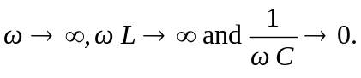 Thus, at high frequencies the current through is nearly zero and the power dissipated by the circuit is
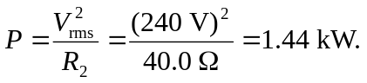
b) Now we let 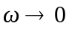, and so 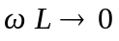and 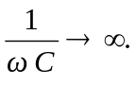Thus, at low frequencies the current through is nearly zero and the power dissipated by the circuit is
